Flipkart Functional Breakdown in Agile Format

Epic 1: User Account Management
Feature 1.1: User Registration & Login
- User Story 1.1.1: New User Sign-Up
As a new user, I want to sign up using my mobile number or email so that I can create an account.
  - Task: Design sign-up form
  - Task: Implement OTP/email verification
  - Task: Save user data securely in DB
- User Story 1.1.2: Returning User Login
As a returning user, I want to log in using OTP/password so I can access my account.
  - Task: Design login form
  - Task: Integrate login API
  - Task: Implement session/token management
Feature 1.2: Profile Management
- User Story 1.2.1: Edit Personal Profile
As a user, I want to update my personal details so my account stays accurate.
  - Task: Add editable form for user details
  - Task: Connect form to update API
  - Task: Implement validation

Epic 2: Product Browsing & Search
Feature 2.1: Product Listing
- User Story 2.1.1: Browse Products by Category
As a user, I want to browse products by category so I can find what I need easily.
  - Task: Build category menu
  - Task: Display products by category
  - Task: Paginate product results

Feature 2.2: Search and Filters
- User Story 2.2.1: Search Products Using Keywords
As a user, I want to search for a product using keywords so I can find it quickly.
  - Task: Implement search bar
  - Task: Integrate search API
  - Task: Show real-time suggestions
- User Story 2.2.2: Apply Product Filters
As a user, I want to filter products by price, brand, and rating so I can refine my search.
  - Task: Add filter UI
  - Task: Apply filters to product API
  - Task: Update results dynamically

Epic 3: Product Details & Reviews
Feature 3.1: Product Detail Page
- User Story 3.1.1: View Product Information
As a user, I want to view product specs and images so I can make informed decisions.
  - Task: Display product info
  - Task: Show image carousel
  - Task: Include specifications and FAQs
Feature 3.2: Reviews & Ratings
- User Story 3.2.1: Read Product Reviews
As a user, I want to see product reviews so I can judge its quality.
  - Task: Fetch reviews from DB
  - Task: Display average rating
  - Task: Add option to sort reviews

Epic 4: Cart & Wishlist Management
Feature 4.1: Add to Cart
- User Story 4.1.1: Save Items in Cart
As a user, I want to add products to my cart so I can buy them later.
  - Task: Implement “Add to Cart” button
  - Task: Store cart items in session/DB
  - Task: Show cart icon count
Feature 4.2: Wishlist
- User Story 4.2.1: Add Items to Wishlist
As a user, I want to save items to my wishlist so I can buy them in the future.
  - Task: Add “Add to Wishlist” button
  - Task: Create wishlist API
  - Task: Display saved items

Epic 5: Checkout & Payments
Feature 5.1: Address Management
- User Story 5.1.1: Save Multiple Addresses
As a user, I want to save multiple addresses so I can choose one during checkout.
  - Task: Add address form
  - Task: Save address to user profile
  - Task: Implement edit/delete functionality
Feature 5.2: Payment Integration
- User Story 5.2.1: Make Online Payment
As a user, I want to pay using card/UPI/wallet so I can complete the order.
  - Task: Integrate payment gateway
  - Task: Secure payment data
  - Task: Handle success/failure callbacks

Epic 6: Order Management
Feature 6.1: Order Tracking
- User Story 6.1.1: Track My Orders
As a user, I want to track my orders so I know their delivery status.
  - Task: Connect with delivery API
  - Task: Show order status on user dashboard
Feature 6.2: Order History
- User Story 6.2.1: View Past Orders
As a user, I want to see my past orders so I can reorder or return items.
  - Task: List all previous orders
  - Task: Enable “Reorder” and “Return” options

Epic 7: Returns & Refunds
Feature 7.1: Return Requests
- User Story 7.1.1: Return Ordered Items
As a user, I want to return an item within return window so I can get a refund.
  - Task: Add “Return” button
  - Task: Validate return eligibility
  - Task: Update order status
Feature 7.2: Refund Processing
- User Story 7.2.1: Receive Refund
As a user, I want to get refunded to my original payment method.
  - Task: Trigger refund API
  - Task: Notify user via SMS/email

Epic 8: Admin & Inventory Management
Feature 8.1: Product Upload & Inventory
- User Story 8.1.1: Admin Adds New Product
As an admin, I want to upload new products with details.
  - Task: Build admin UI
  - Task: Add form validations
  - Task: Update inventory DB
Feature 8.2: Order & User Management
- User Story 8.2.1: Admin Manages Orders & Users
As an admin, I want to manage orders and users to ensure smooth operation.
  - Task: View/manage user database
  - Task: Update order statuses
  - Task: Generate reports

Azure DevOps Portal View
EPIC:
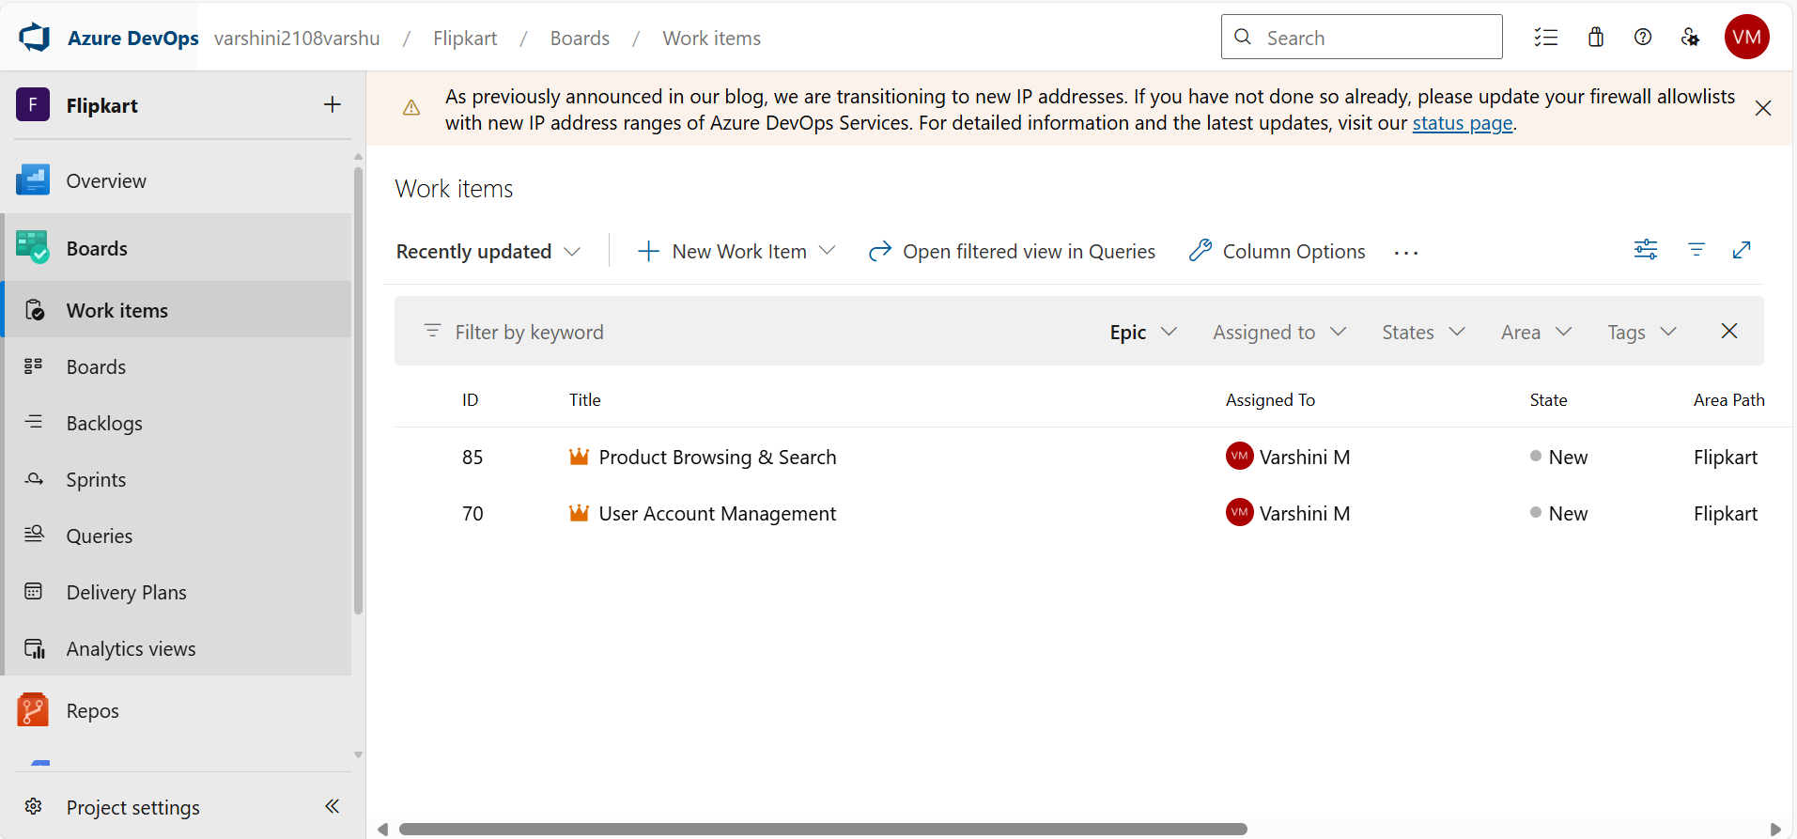

Features: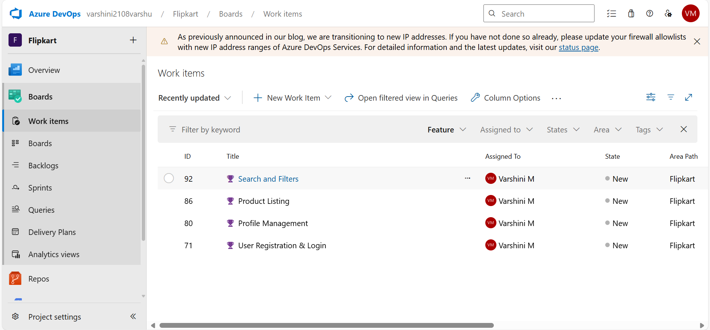

User Story:
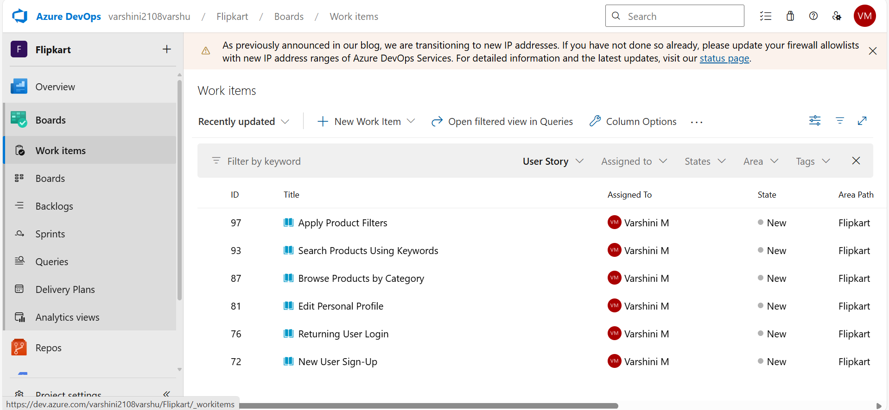

Tasks:
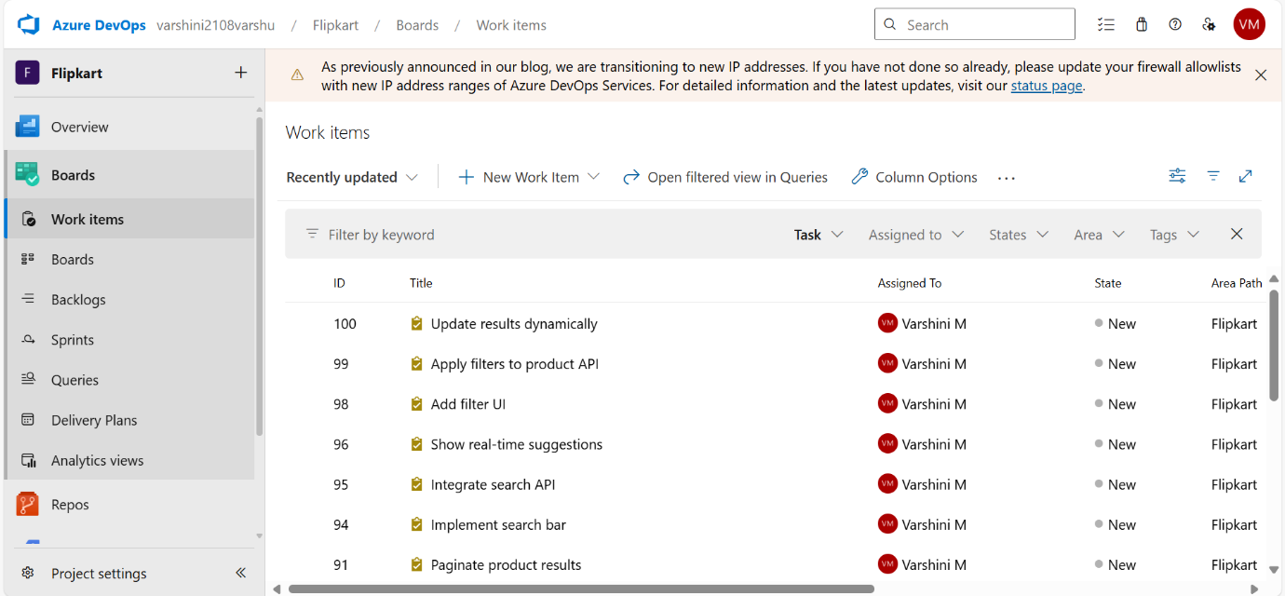
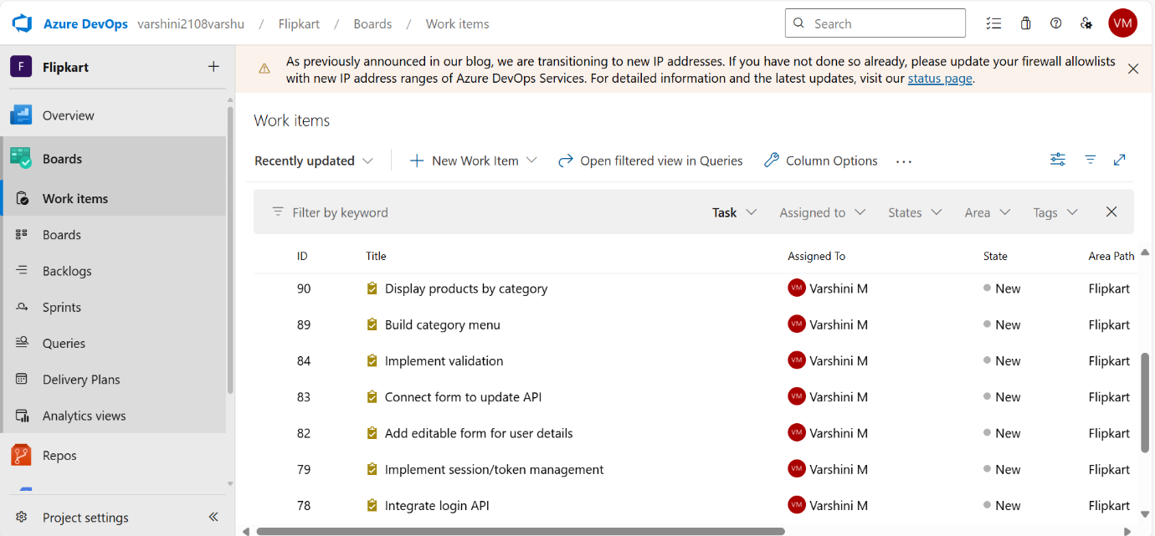
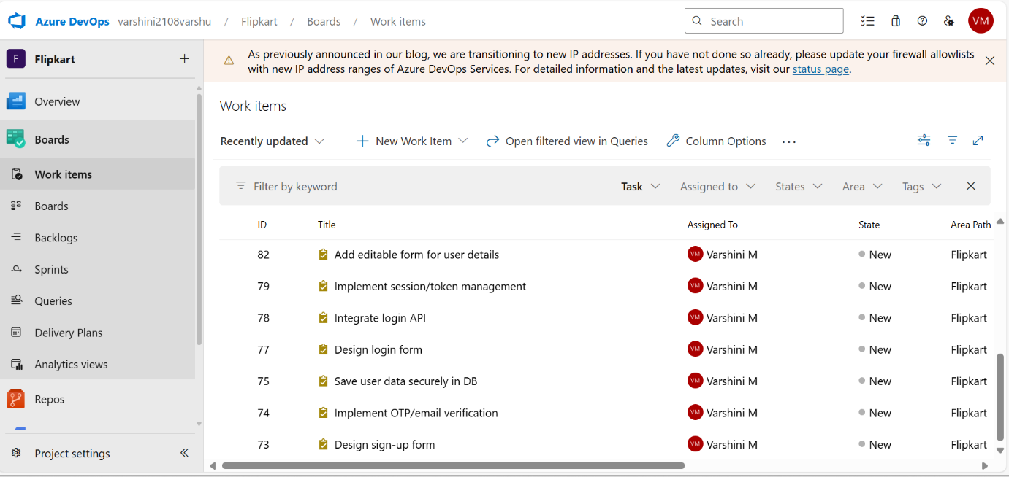
Boards:
